# SKYFALL GAME

### A PROJECT REPORT

***Submitted by***

**Devicharan Dasari–92100938019 Adityaraj Chudasma–92100938023 Smit Rudakiya–92100938029 Vandit Doshi–92100938050**

***In partial fulfilment for the award of the degree of***

**DIPLOMA ENGINEERING**

***in***

**Computer Engineering**



**Faculty of Diploma Studies Marwadi University, Rajkot**



**Marwadi University, Rajkot Faculty of Diploma Studies** Computer Engineering Department **2023-24**

**CERTIFICATE**

This is to certify that the project entitled **SkyFall Game** has been carried out by **Devicharan Dasari (92100938019)** under my guidance in partial fulfilment of the degree of Diploma Engineering in Computer Engineering (6th Semester) of Marwadi University, Rajkot during the academic year 2023-24.

Date :

**Internal Guide Head of the Department**

Prof. Sumit Makwana Prof. Mittal Joiser

Assistant Professor Computer Engineering



**Marwadi University, Rajkot Faculty of Diploma Studies** Computer Engineering Department **2023-24**

## CERTIFICATE

This is to certify that the project entitled **SkyFall Game** has been carried out by **Adityaraj Chudasma (92100938023)** under my guidance in partial fulfilment of the degree of Diploma Engineering in Computer Engineering (6th Semester) of Marwadi University, Rajkot during the academic year 2023-24.

Date :

**Internal Guide Head of the Department**

Prof. Sumit Makwana Prof. Mittal Joiser

Assistant Professor Computer Engineering



**Marwadi University, Rajkot Faculty of Diploma Studies** Computer Engineering Department **2023-24**

## CERTIFICATE

This is to certify that the project entitled **SkyFall Game** has been carried out by **Smit Rudakiya (92100938029)** under my guidance in partial fulfilment of the degree of Diploma Engineering in Computer Engineering (6th Semester) of Marwadi University, Rajkot during the academic year 2023-24.

Date :

**Internal Guide Head of the Department**

Prof. Sumit Makwana Prof. Mittal Joiser

Assistant Professor Computer Engineering



**Marwadi University, Rajkot Faculty of Diploma Studies** Computer Engineering Department **2023-24**

## CERTIFICATE

This is to certify that the project entitled **SkyFall Game** has been carried out by **Vandit Doshi (92100938050)** under my guidance in partial fulfilment of the degree of Diploma Engineering in Computer Engineering (6th Semester) of Marwadi University, Rajkot during the academic year 2023-24.

Date :

**Internal Guide Head of the Department**

Prof. Sumit Makwana Prof. Mittal Joiser

Assistant Professor Computer Engineering

|  |  |
| --- | --- |
| **Contents** |  |
| **Acknowledgements** | **I** |
| **Abstract** | **II** |
| **List of Tables** | **III** |
| **List of Figures** | **IV** |
| 1. **Introduction** | **1** |
| 1.1. Document purpose | 1 |
| 1.2. Product scope | 1 |
| 1.3. Intended audience and document overview | 1 |
| 1.4. Definitions and abbreviations | 2 |
| 1.5. Document conventions | 3 |
| 1.6. References and acknowledgments | 3 |
| 2. **Overall description** | **4** |
| 2.1. Product perspective | 4 |
| 2.2. Product functionality | 5 |
| 2.3. Users and characteristics | 5 |
| 2.4. Operating environment | 5 |
| 2.5. Design and implementation constraints | 6 |
| 2.6. User documentation | 6 |
| 2.7. Assumptions and dependencies | 6 |
| 3. **Specific requirements** | **7** |
| 3.1. External interface requirements | 7 |
| 3.2. Functional requirements | 9 |
| 3.3. Behavior requirements | 10 |
| 4. **Other non-functional requirements** | **18** |
| 4.1. Performance requirements | 18 |
| 4.2. Safety and security requirements | 18 |
| 4.3. Software quality attributes | 18 |
| **Appendix A – Data Dictionary** | **19** |
| **Appendix B – Plagiarism Report** | **22** |
| **Appendix C – User Manual** | **24** |

# Acknowledgement

With great pleasure, we offer this report, which serves as the final project of our Diploma in Computer Engineering journey. It is a reflection of our dedication and hard work.

Our heartfelt thanks go to all who supported us during this project. We're especially grateful to Prof. Surbhi Palkar for her invaluable guidance, as well as our faculty members who played a vital role in our academic journey.

We also extend our appreciation to our project guide and fellow faculty members for their consistent guidance and motivation. Your contributions were pivotal.

To everyone who shaped our project and enriched our understanding, we're thankful for your unwavering support. Your wisdom, guidance, and encouragement were instrumental in our success.

# Abstract

Gesture Fun is an exciting web-based game that allows users to control in-game actions using hand gestures. This interactive web app combines HTML, CSS, JavaScript, and python to create an engaging user interface. The game utilizes the user's webcam to capture hand movements, and computer vision techniques process these gestures in real-time.

The Python-based server handles gesture recognition and communicates with the web app. Players can perform swipes, taps, and other gestures to navigate characters, trigger actions, and interact with the game environment. Gesture Fun offers an immersive and enjoyable gaming experience, appealing to a broad audience.

The system demonstrates how the integration of a fairly accurate, light weight hand detection model can be used to track player hands and enable real-time body-as-input interactions. The web app enjoyment, offering players a unique way to interact with the game.

# List of Table

1. Table 1.1 Player login Table 18
2. Table 2.1 Player High Score Table 18
3. Table 2.7.1 RAM & CPU Consumptions 18
4. Table 2.7.2 OS Requirements 18
5. Table 3.1 Achievements Table 19
6. Table 4.1 Leaderboard Table 19
7. Table 4.1.1 Easy Leaderboard Table 19
8. Table 4.1.2 Medium Leaderboard Table 19
9. Table 4.1.3 Hard Leaderboard Table 20

**List of Figures**

1. Figure 3.3.1 Use case Diagram 10
2. Figure 3.3.2 E.R Diagram 11
3. Figure 3.3.3 Activity Diagram 12
4. Figure 3.3.4 Sequence Diagram 13
5. Figure 3.3.5.1 DFD Diagram(Level 0) 14
6. Figure 3.3.5.2 DFD Diagram(Level 1) 15
7. Figure 3.3.5.3 DFD Diagram(Level 2) 16
8. Figure 3.3.6 Class Diagram 17
9. Figure 2.1 Flowchart 4
10. Figure 3.1.1.1 Play Interface 7
11. Figure 3.1.1.2 Difficulty 8

# Introduction

What is skyfall web application is about? Well, imagine using your computer to play a game, and instead of a keyboard or mouse, use your hands in front of a camera. It's like magic! We're making a guide to show everyone how to create this kind of amazing software. With using of combines different technologies like web development (HTML, CSS, JavaScript, PHP, Python).

This document is crucial because it lays out exactly what we need to do to build our web application. It explains our goals, what the software should do, and any limits or challenges we might face. Whether you're a developer, a tester, or someone keeping an eye on the project, this document will be your go- to resource for understanding what we're creating and how we're going to do it.

### Document Purpose

The purpose of this document is to provide a roadmap for our project. It keeps us on track and helps us make to sure our software works just the way we want it to. In short, this document is our recipe for creating a web application that will amaze and engage users in a whole new way.

Its objectives are to set the objectives of our project, describe how this project will function, and provide the guidelines we have to follow to. This paper is your key to understand what we're doing and how we're doing it, whether you're a developer, tester, or someone who is excited about our project.

### Product Scope

It defines what our software will include and what it won't. Think of it as a blueprint for our project. Our focus is on creating a captivating experience where users interact with the computer using hand gestures. We'll craft the game, design the rules, and ensure it's enjoyable.

We want to highlight that the product scope sets clear rules for our project, ensuring a smooth development process and an exciting game for users as the main benefits. It guarantees that the game will be amazing and give you a unique way to play on your computer. Users will enjoy experiencing the magic of hand gesture control.

This is really helpful because it makes sure everyone knows what we're building. It helps our team work efficiently, so we don't get confused about what the game should be. So, think of our project's scope as the plan that makes sure everything goes smoothly and you get to enjoy a fantastic game.

### Intended Audience and Document Overview

* + - **Gamers:** Describe the primary target audience, which includes gamers of a certain age group, interests, and gaming preferences. Are you targeting casual game.
    - **Platform:** Specify the platforms your game supports, such as desktop web browsers.
    - **Experience Level:** Consider whether the game is designed for beginners, intermediate players, or experts in gesture-based gaming.
    - **Age Group:** Mention if the game is suitable for children, teenagers, adults.
    - **Introduction:** Provide a brief introduction to the document, explaining its purpose and what readers can expect to find.
    - **Game Description:** Summarize the key features and concept of the gesture-controlled web- based game. Highlight what sets it apart from other games.
    - **System Requirements:** Explain how to run the game, including hardware (Webcam) & software (Web Browser) requirements.
    - **Game Controls:** Detail the gesture controls and how players can interact with the game using gestures. Provide clear instructions.
    - **Gameplay Overview:** Describe the gameplay mechanics, objectives.
    - **Scoring and Achievements:** Explain how scoring works, and mention any achievements or rewards players can earn.
    - **Troubleshooting:** Include a section on common issues players may encounter and how to resolve them.
    - **Contact Information:** Provide contact details for customer support or inquiries.
    - **Conclusion:** Summarize the document and encourage readers to start playing the game.

### Definitions, and Abbreviations

|  |  |
| --- | --- |
| HTML | Hyper Text Markup Language |
| CSS | Cascading Style Sheet |
| PHP | Hypertext Preprocessor |
| OS | Operating System |
| 2D | 2 Dimensional |
| FPS | Frames Per Second |
| RAM | Random Access Memory |
| MB | Mega Bytes |
| CPU | Central Processing Unit |
| OpenCV2 | Open-Source Computer Vision Library Version 2 |
| App | Application |
| i3 | Intel Core 3 Processor |
| i7 | Intel Core 7 Processor |

* 1. **Document Conventions**

We use specific formatting and naming rules so that everyone on the team can read and understand it easily. We also have conventions for how we name files and folders to keep everything in its right place. These conventions are like a set of guidelines that make our work smoother and more consistent.

We conventions to maintain consistency and clarity in our documentation. Think of these as the agreed-upon rules for how we format and present information.

When it comes to coding, we adhere to coding standards, which include consistent indentation, naming conventions, and comments to make our code more readable and maintainable.

### References and Acknowledgments

1. developers - <https://developers.google.com/mediapipe/solutions/vision/gesture_recognizer/web_js>
2. geeksforgeeks - <https://www.geeksforgeeks.org/project-idea-hand-web-browser/>
3. towardsdatascience-[https://towardsdatascience.com/gentle-introduction-to-2d-hand-pose-](https://towardsdatascience.com/gentle-introduction-to-2d-hand-pose-estimation-approach-explained-4348d6d79b11) [estimation-approach-explained-4348d6d79b11](https://towardsdatascience.com/gentle-introduction-to-2d-hand-pose-estimation-approach-explained-4348d6d79b11)
4. makeuseof -<https://www.makeuseof.com/browser-windows-macos-chromeos-uses-least-ram-cpu/>
5. w3school - [https://www.w3schools.com/](https://www.w3schools.com/js/default.asp)
6. <http://ethesis.nitrkl.ac.in/6055/1/110ID0520-14.pdf>
7. <https://www.ijsr.net/archive/v11i10/SR221025224232.pdf>

# Overall Description

### Product Perspective

The concept of "product perspective" describes the point of view or strategy used when creating, managing, and marketing a product. It covers a range of topics, such as the features, usability, and overall user experience of the product**.**

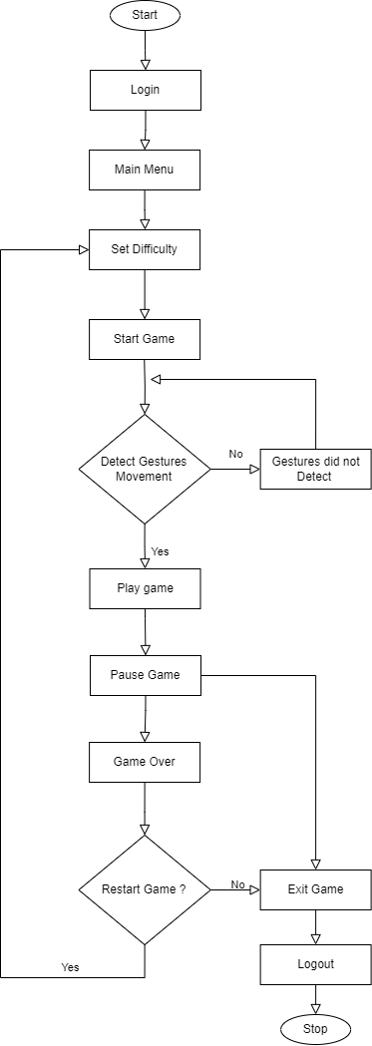

*Figure 2.1 FLOWCHART*

A flowchart is a visual diagram that uses symbols and arrows to represent the steps, decisions, and flow of a process or system. It's like a map that shows how things are done, making it easier to understand, analyze, and improve processes or procedures

### Product Functionality

* + 1. **Web App Game:** It’s a web app game and it concept is like old time but the new thing is gesture control and it will give user brand new experience to play game.
    2. **Gesture Control:** In the game instead of keyboard, mouse, remote control. We will be going to use gesture control it will be new experience for user to play game like this.
    3. **Achievements:** Achievements in a provide players with goals and challenges, motivating them to explore and master the game's gesture controls. They enhance engagement, satisfaction, and community interaction by rewarding players for their accomplishments, contributing to the game's long-term appeal.

### Users and Characteristics

* + 1. **Players:** These are the primary users of our skyfall game. They can be people of various ages and enjoy interactive and engaging gaming experiences. Characteristics include a various difficulty of game.
    2. **Developers:** The individuals responsible for building and maintaining the web application. They need technical proficiency in web development, computer vision, and programming languages like HTML, CSS, PHP, JavaScript and Python.
    3. **Designer:** Game designers must be specialists in creating simple controls that react effectively to these motions. The game must strike the correct balance between excitement and accessibility so that players of all skill levels may enjoy it. In this manner, a variety of players can enjoy the game.
    4. **Testers:** Individuals tasked with ensuring the application functions correctly and meets quality standards. They require attention to detail and an understanding of testing procedures.

### Operating Environment

It can use in any device but minimum requirement for OS windows 7 and any web browser, and for hardware minimum webcam of 30 fps. Maximum requirement for OS windows 11, for browser any latest version of web browser and for hardware webcam of 260 fps.

### Design and Implementation Constraints

* 2D Graphics
* Not Too Fancy Graphics
* Browser compatibility
* Responsive
* Latency

### User Documentation

It is user friendly web-based game. It is easy to use and for control use have just move his/her hand and the pointer will move as hand. In web site use get instruction for how to operate game properly.

### Assumptions and Dependencies

Here are the RAM and CPU consumption figures for all browsers on a Windows device:

*Table 2.7.1 RAM & CPU Consumptions*

|  |  |  |
| --- | --- | --- |
| **Browser Name** | **RAM Usage (MBs)** | **CPU Usage (Percentage)** |
| Microsoft Edge | 825-900 | 3-7 |
| Opera | 850-950 | 12-34 |
| Mozilla Firefox | 950-1000 | 5-11 |
| Google Chrome | 950-1000 | 7-25 |

To run game this are the minimum and recommend device:

*Table 2.7.2 System Requirements*

|  |  |  |
| --- | --- | --- |
| **Minimum** | | |
| **OS** | **RAM** | **CPU** |
| Windows 7/ Linux /MacOS X | 4GB | i3-8100 |
| **Recommend** | | |
| Windows 10/ Linux/ MacOS 12 | 8GB | i5-12450H |

# Specific Requirements

### External Interface Requirements

##### User Interfaces

This is our project, and the web page for our website has been implemented. This is the play interface and this is the user interface of our offline game.

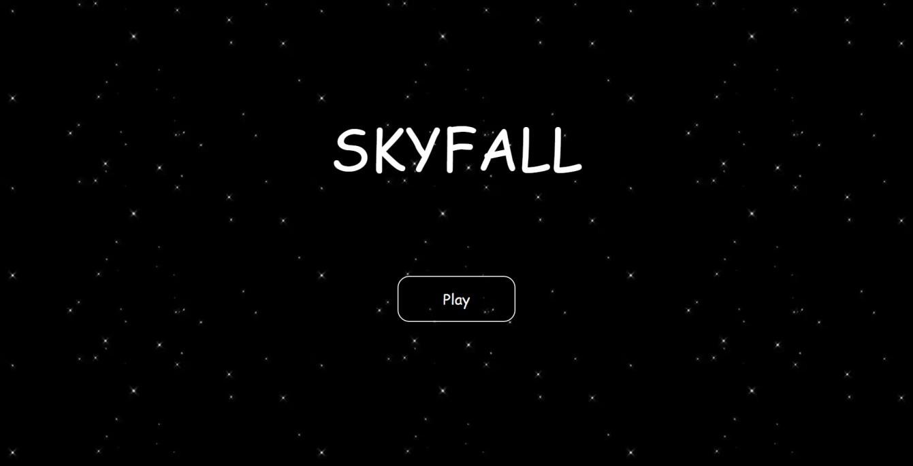

*Figure 3.1.1.1 Play Interface*

Additionally, this interface will appear when the user clicks the "Play" button. Once the game difficulty is set, you can choose between three different levels of difficulty using this interface. Then the game starts. After the game's launch, various colored balls will fall, and movable bricks that can be controlled with hand gestures will be that is below. And after that, we can catch the balls with the help of Movable Brick. The player will be given three chances. If the player attempts to catch the red ball, one life will be deducted; if three lives are lost, the game is over. Then there is the Pause option, which allows the user to pause the game. Within this option, there are multiple options: Resume, Restart, Change Settings, and Quit.

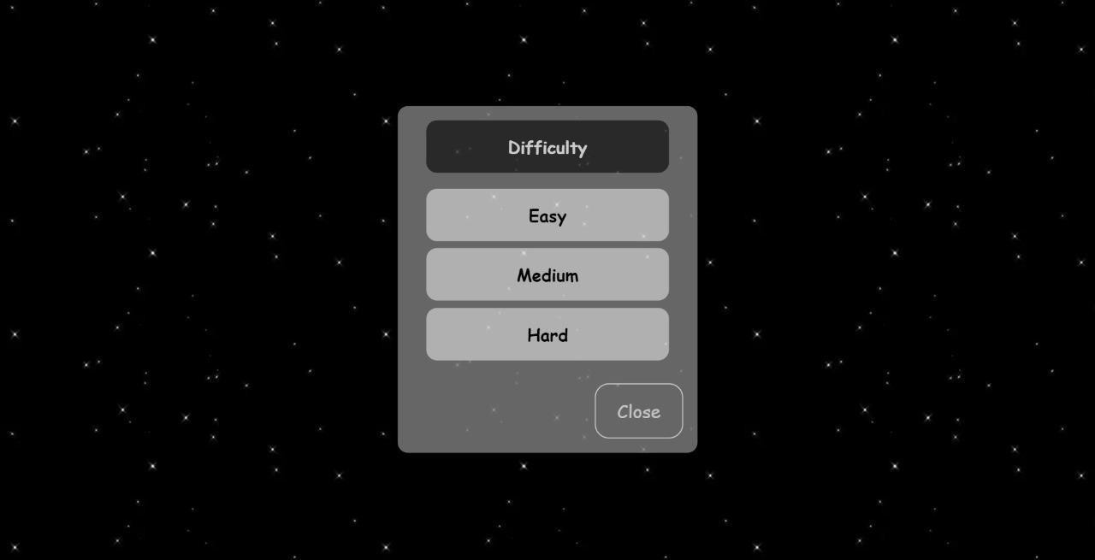

*Figure 3.1.1.2 Difficulty*

##### Hardware Interfaces

The hardware in our project is used to control the user's hand gestures. A laptop or computer, as well as a webcam or system camera, make up the hardware.

The libraries will be use are OpenCV (cv2) or TensorFlow

A software library for machine learning and computer vision is called OpenCV (Open-Source Computer Vision Library). A machine learning software library available for free and open source is called TensorFlow.

##### Software Interfaces

A web browser is required for our project as the software interface. and TensorFlow or OpenCV (cv2) as a library.

##### Communications Interfaces

The client-side code might carry out some basic validation, like verifying that the input satisfies certain requirements or that the username and password fields are filled out correctly. The request is processed by the server-side components, who also validate the user's credentials and compares them with the database. As it processes the database response, it makes sure the information is correct, matches the user's login information, and isn't fake.

The requested user data is sent back to the server-side component by the database once it has processed the query. At this point, the user is considered as authenticated and is able to access their progress, game profile, and other related information. To keep the user's authentication status secure during their gaming session, use the session token or cookie.

### Functional Requirements

1. **Web App Game:** The concept of this web app game is similar to that of the past, but gesture control is new and will provide a whole new gaming experience for the user.
2. **Gesture Control:** Instead of a keyboard, mouse, and remote control in the game. We're going to use gesture control, which will give users a new gaming experience.
3. **Achievements:** Players are encouraged to learn and become comfortable with the game's gesture controls by the goals and challenges that achievements in a provide them. By rewarding players for their achievements, they improve engagement, satisfaction, and community interaction, which adds to the game's overall attraction.
4. **Difficulty:** Three different levels of difficulty are available in the game, and each level will work differently from the others. It is categorized as Easy, Medium, or Hard. Based on their name, the user will be able to choose from a variety of modes and levels of difficulty.
5. **Leader Board:** The Leader Board will show the highest scoring users and their entry game scores, allowing users to surpass each other's high scores.

### Behaviour Requirements

#### Use Case View:

A use case diagram at its simplest is a representation of a user's interaction with the system and depicting the specifications of a use case. A use case diagram can portray the different types of users of a system and the various ways that they interact with the system. This type of diagram is typically used in conjunction with the textual use case and will often be accompanied by other types of diagrams as well.

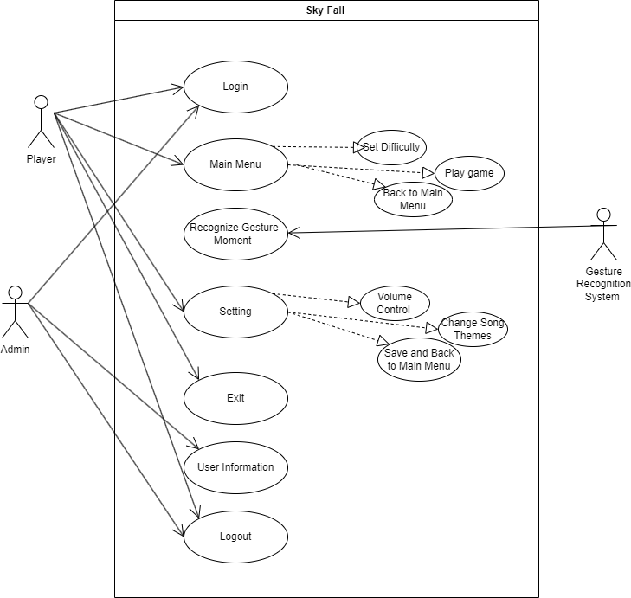

*Figure 3.3.1 USECASE DIAGRAM*

#### E.R Diagram:

An Entity-Relationship Diagram (ERD) is like a map for organizing information in a database. It usies shapes to represent things called "entities" (like customers or products) and lines to show how these entities are connected or related. It's a way to plan how data is stored and linked together in a database, helping people design and understand how information fits together in a structured way. Think of it as a visual tool to plan and explain how data should be organized and linked in a database system.

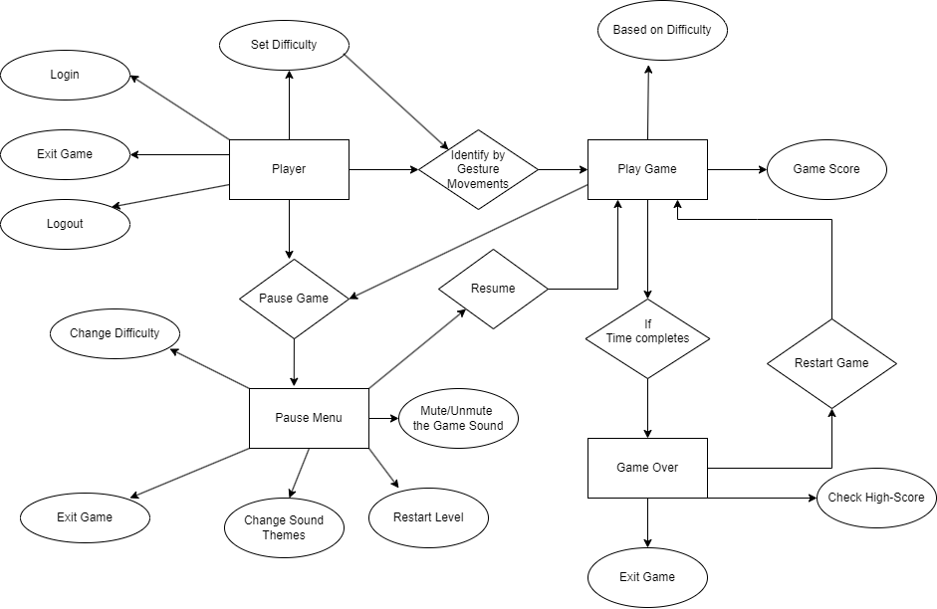

*Figure 3.3.2 ER DIAGRAM*

#### Activity Diagram:

An activity diagram is a graphical representation that helps illustrate the workflow or sequence of actions in a process or system. It uses specific symbols to represent different activities, such as tasks, decisions, and branching points.

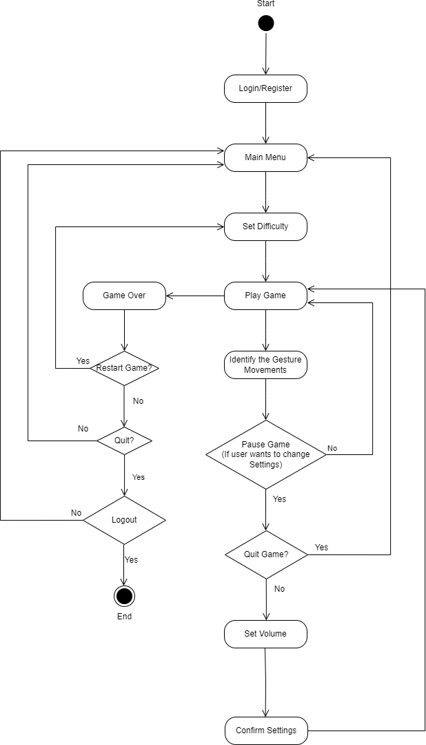

*Figure 3.3.3 ACTVITY DIAGRAM*

#### Sequence Diagram:

Sequence diagram display the time sequence of the objects participating in the interaction. Sequence diagram are used to visualize and explore the interaction between the users, screens and the object instances within the system. They provide an ordered sequential map of messages passing between objects over time. The sequence diagram is typically represented by a horizontally deployed set of the actors and object instances, each having a verified life span bar. Messages are drawn from one object to another with an arrow indicating the direction of flow.

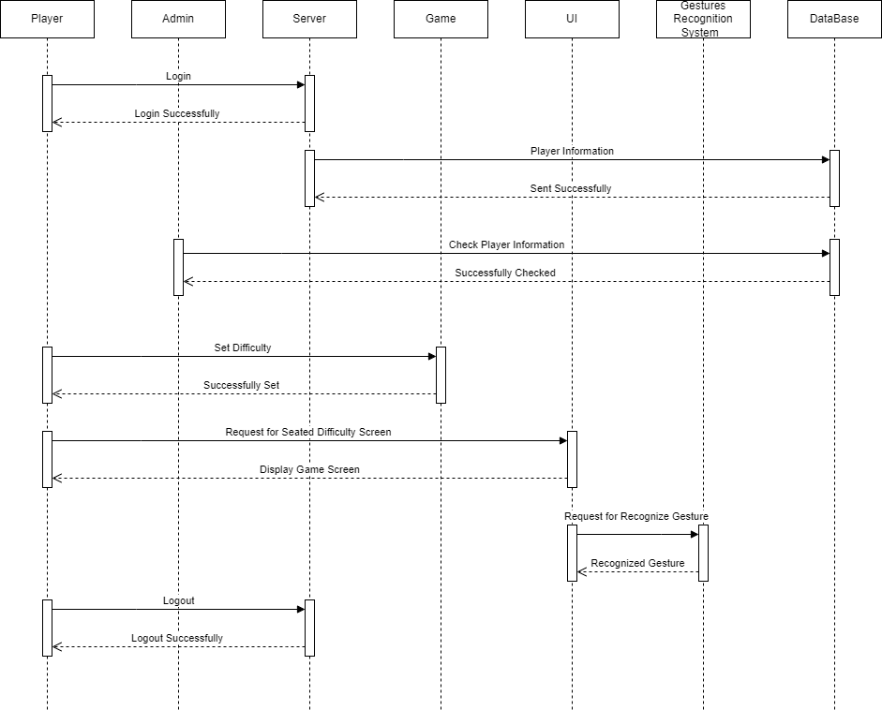

*Figure 3.3.4 SEQUENCE DIAGRAM*

#### DFD Diagram(Level 0):

A Level 0 Data Flow Diagram (DFD) provides a high-level overview of how data flows within a system. It typically consists of processes, external entities, and data stores.

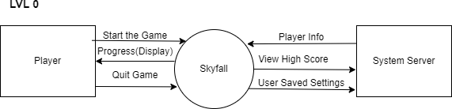

*Figure 3.3.5.1 DFD LVL 0*

#### DFD Diagram(Level 1):

A Level 1 Data Flow Diagram (DFD) provides a high-level overview of how data flows within a system. It typically includes processes, data sources, data destinations, and the data flow between them.

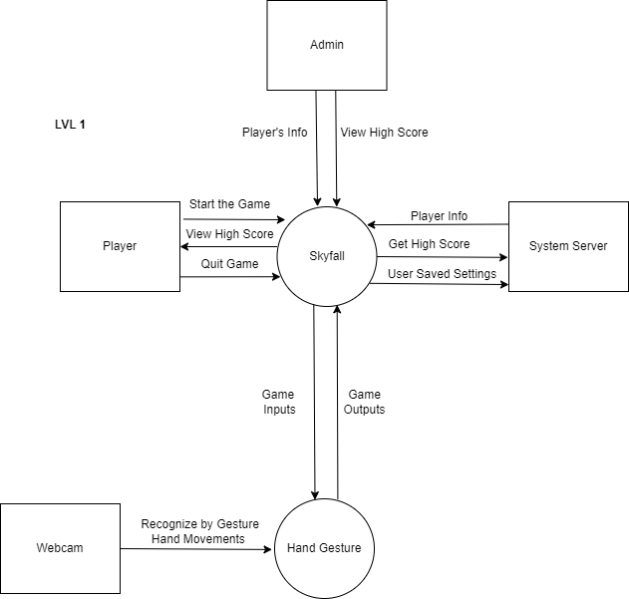

*Figure 3.3.5.2 DFD LVL 1*

#### DFD Diagram(Level 2):

A Data Flow Diagram (DFD) Level 2 is a detailed representation of a specific part of a system or process that was previously shown at a higher level in a Level 1 DFD. It provides a more in-depth view of how data flows within that particular subsystem or process.

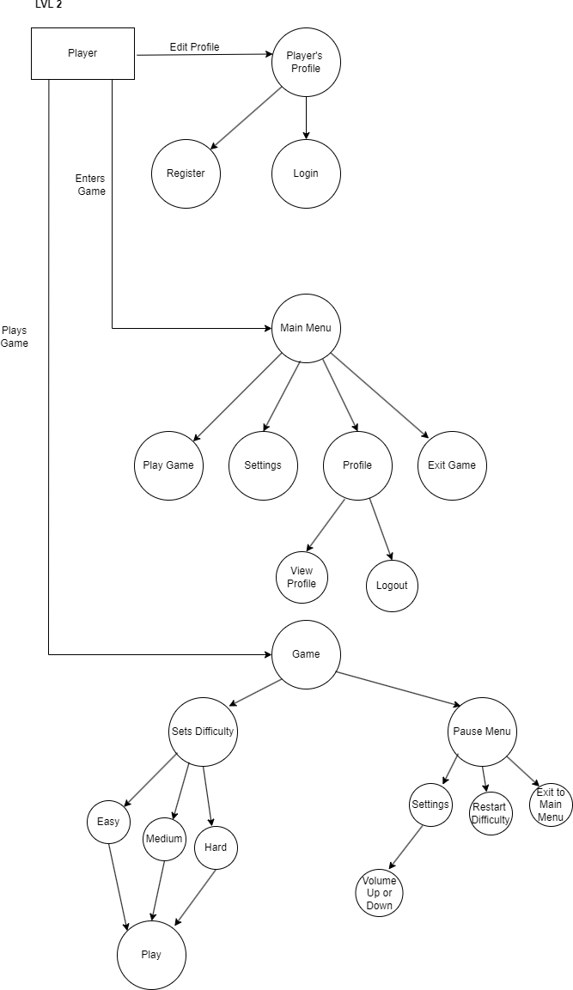

*Figure 3.3.5.3 DFD LVL 2*

#### 3.3.6 Class Diagram:

A class diagram is like a blueprint for a software system. It shows the different types of objects (called classes) in the system and how they relate to each other. These classes represent the building blocks of the software and define their attributes (properties) and behaviors (methods). It's a visual way to understand the structure of a software application and how its parts work together.

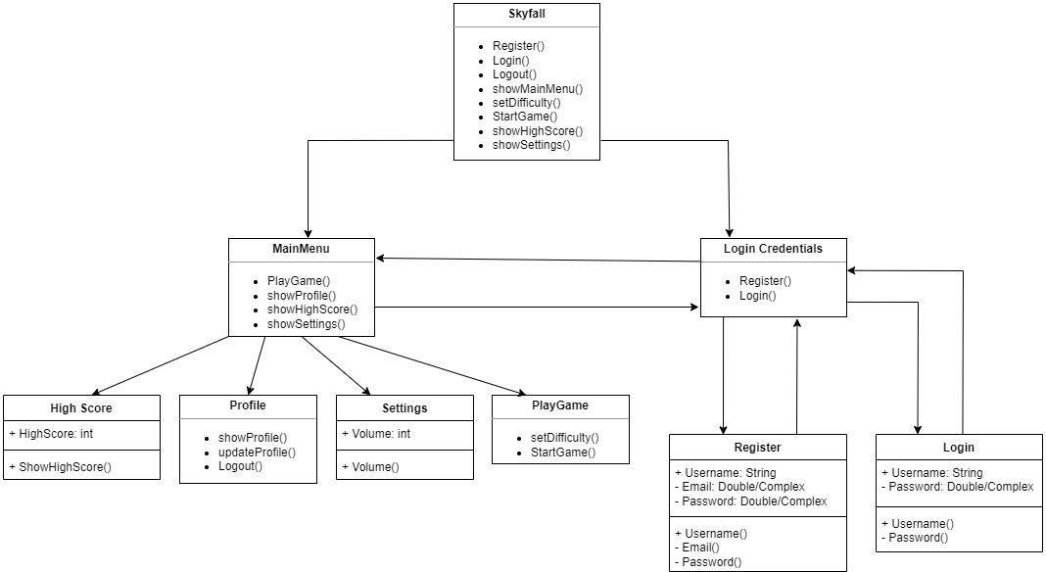

*Figure 3.3.6 CLASS DIAGRAM*

# 4. Other Non-functional Requirements

### Performance Requirements

**Gesture Recognises:** For recognising gesture it may take 5 to 10 seconds.

**Latency:** In order for a game to seem responsive, it has to have low latency, which may be impacted by gesture delays and device performance.

**Performance Testing:** To confirm that the system can support a certain number of concurrent users without performance decreasing, performance testing should be done.

**Enhanced Offline Experience:** To keep players interested and satisfied, unique features or material created for offline play should be taken into account.

**Data Privacy:** To preserve privacy even when offline, all user data kept locally should be properly encrypted and protected.

### Safety and Security Requirements

**Data Confirmation:** Ask the user to confirm any transition offline mode.

**Data Removal:** Give people the chance to remove any locally saved data. Make sure the device is securely erased of any deleted data.

### Software Quality Attributes

**Adaptability:** The capacity of a system to adapt to and work well under changing situations or surroundings.

**Flexibility:** Ability of the system to accept changes and adjustments without major changes.

**Portability:** Easy portability or usage of the system across many settings or systems.

**Reusability:** Possibility of slightly modifying the system to be utilized in numerous circumstances or for various purposes.

# Appendix A – Data Dictionary

##### Table 1. Player Login Table:

***TABLE 1.1 PLAYER LOGIN***

|  |  |  |  |
| --- | --- | --- | --- |
| **Attributes** | **Type** | **Size** | **Description** |
| Username(Primary Key) | Varchar2 | 50 | Gives Unique Idenity |
| Password | Varchar2 | 50 | Secures the Information |
| Email | Varchar2 | 50 | Stores email of users |

##### Table 2. Player High Score Table:

*TABLE 2.1 HIGH SCORE LOGIN*

|  |  |  |  |
| --- | --- | --- | --- |
| **Attributes** | **Type** | **Size** | **Description** |
| Username(Primary Key) | Varchar2 | 50 | Gives Unique Idenity |
| Esay High Score | Number | 10000 | Shows esay high score |
| Medium | Number | 10000 | Shows medium high score |
| Hard | Number | 10000 | Show hard high score |

##### Table 3. Achievements Table:

*TABLE 3.1 ACHIEVEMENTS TABLE*

|  |  |  |  |  |
| --- | --- | --- | --- | --- |
| **Attributes** | **Type** | **Size** |  | **Description** |
| Achievement ID | Number | 50 |  | Unique Achievement Identity |
| Achievement Name | Varchar2 | 100 | - | Name of the Achievement |
| Achievement Description | Varchar2 | 5000 |  | Description of the Achievement |

##### Table 4. Leaderboard Table:

###### Esay Table:

*TABLE 4.1 ESAY TABLE*

|  |  |  |  |  |
| --- | --- | --- | --- | --- |
| **Attributes** | **Type** | **Size** | **Primary Key/Foreign Key** | **Description** |
| Username | Varchar2 | 50 | Primary Key | Gives Unique Idenity |
| High Score | Number | 10000 | --- | User’s High Score |
| Difficulty-Easy | Varchar2 | 50 | --- | User Played in Easy difficulty |

###### Medium Table:

* 1. *MEDIUM TABLE*

|  |  |  |  |  |
| --- | --- | --- | --- | --- |
| **Attributes** | **Type** | **Size** | **Primary Key/Foreign Key** | **Description** |
| Username | Varchar2 | 50 | Primary Key | Gives Unique Idenity |
| High Score | Number | 10000 | --- | User’s High Score |
| Difficulty-Medium | Varchar2 | 50 | --- | User Played in Medium difficulty |

###### Hard Table:

*TABLE 4.3 HARD TABLE*

|  |  |  |  |
| --- | --- | --- | --- |
| **Attributes** | **Type** | **Size** | **Description** |
| Username | Varchar2 | 50 | Gives Unique Idenity |
| High Score | Number | 10000 | User’s High Score |
| Difficulty-Hard | Varchar2 | 50 | User Played in Hard difficulty |

# Plagiarism Report

### Acknowledgement:

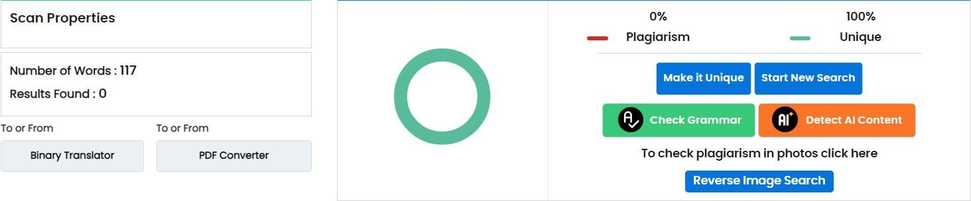

* + 1. 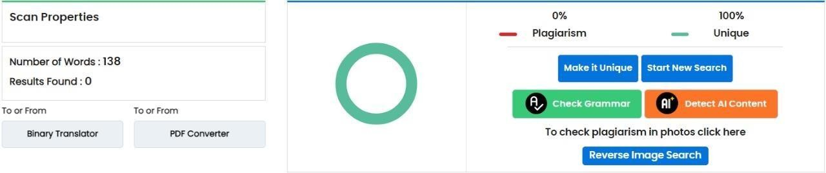**Abstract:**

### Introduction:

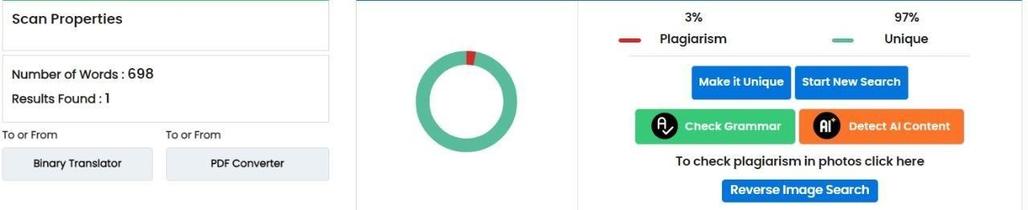

* + 1. **Overall Description:**

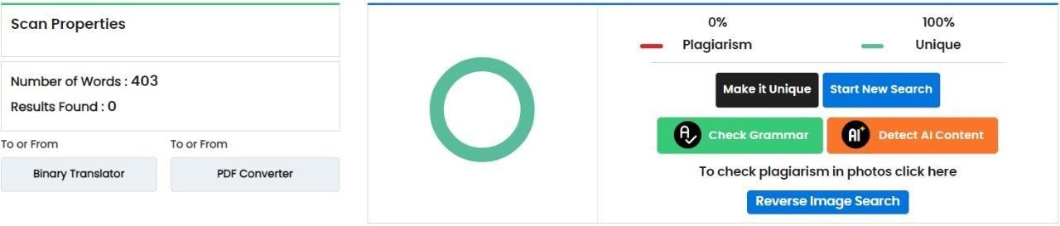

### Specific Requirements:

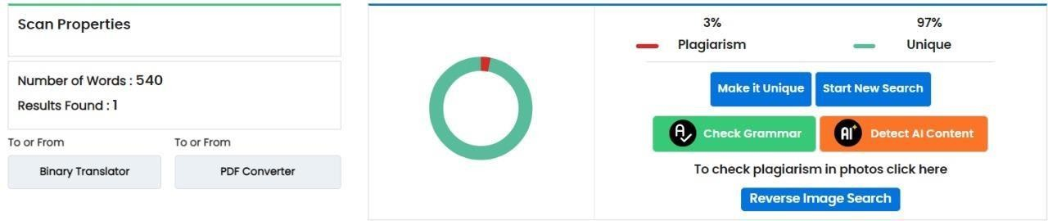

* + 1. **Other Non-Functional Requirements:**

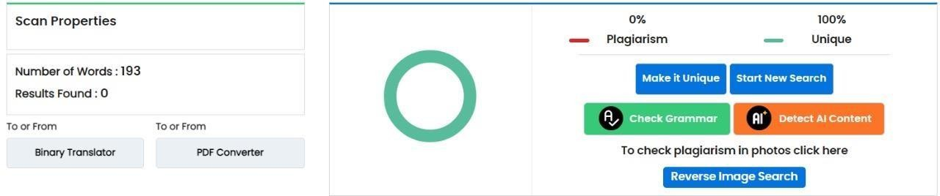

# User Manual

##### Registration:

When user enters in web-site/app then user have to register in it.

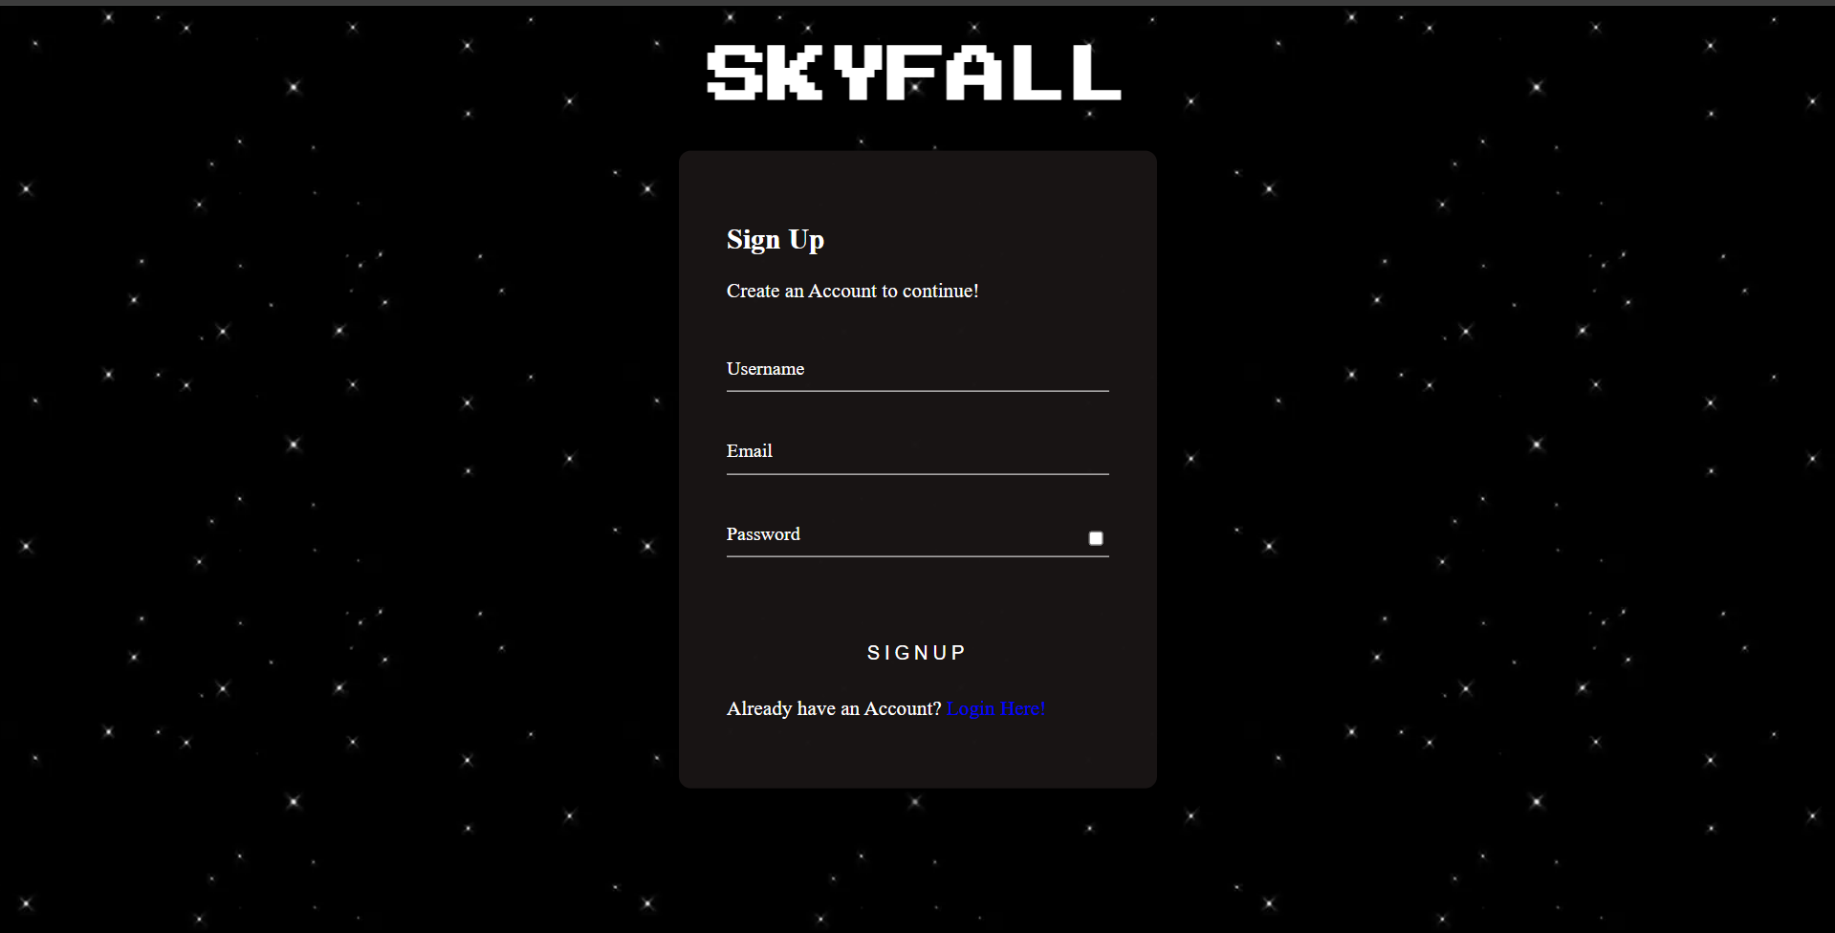

Here user will register by filling this information of it. Every user needs to set unique username. And user will fill these three information Username, Email, Password.

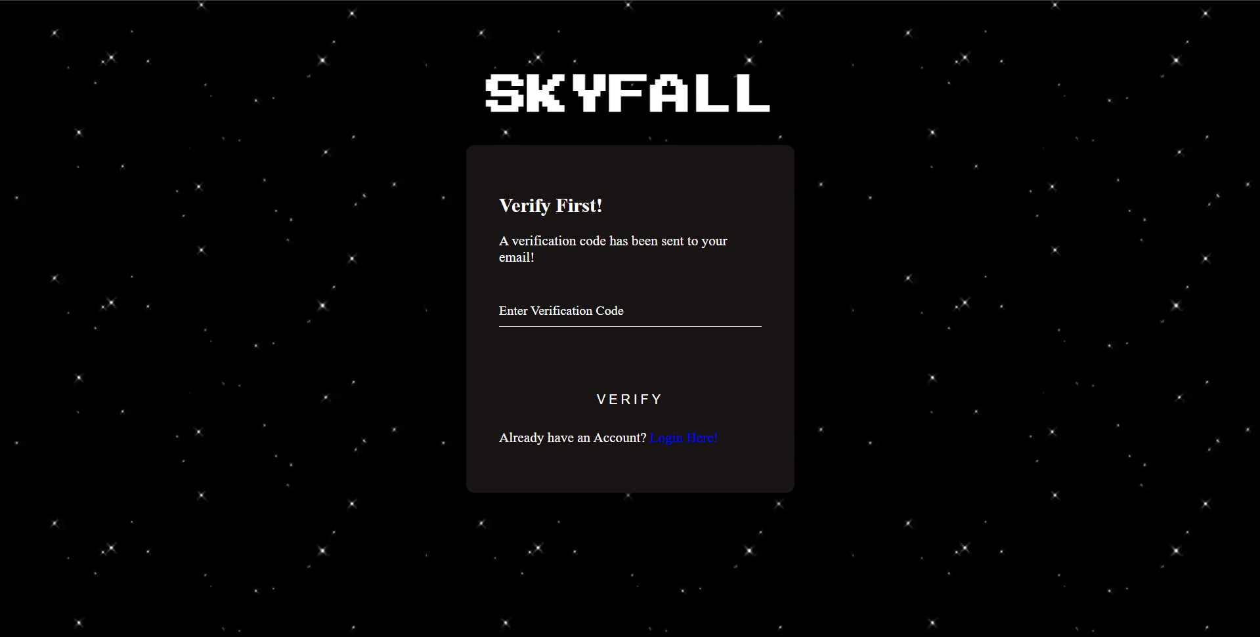

When user registers verification code has been sent to their email, copy that code and paste it in this page and verify their email.

##### Login:

After user have registered their ID then user have to login into the site.

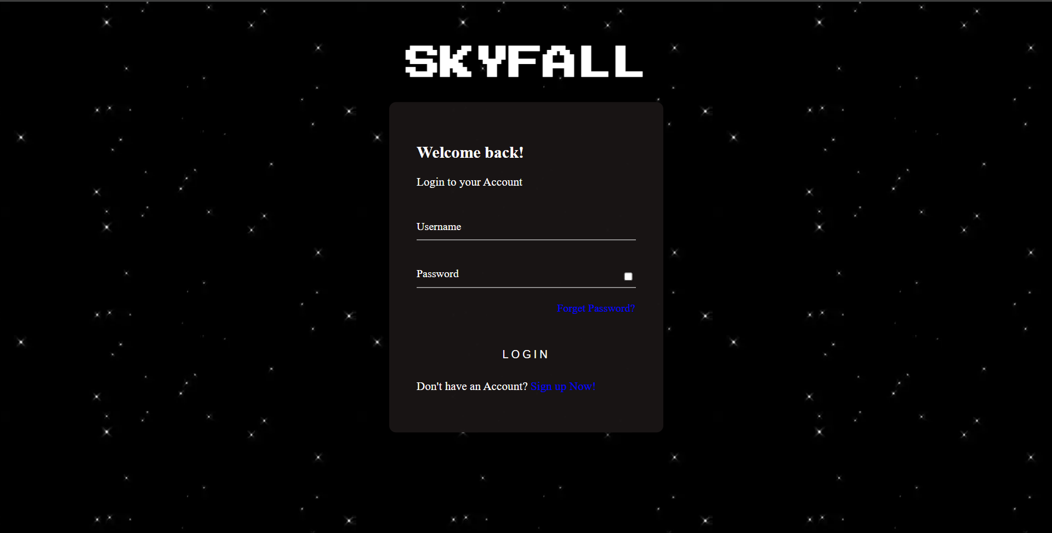

Here user will login into the site by Username and Password that sets in registration. And if user has forgotten their password, then user can reset their password or if user come direct on this page and didn’t register, then there is option down there for sign up now/ registration. Then after user see next interface on their screen

##### Reset Password:

If user has forgot the password of their ID, then by clicking on email and by entering their email they will get a password reset link in their email.

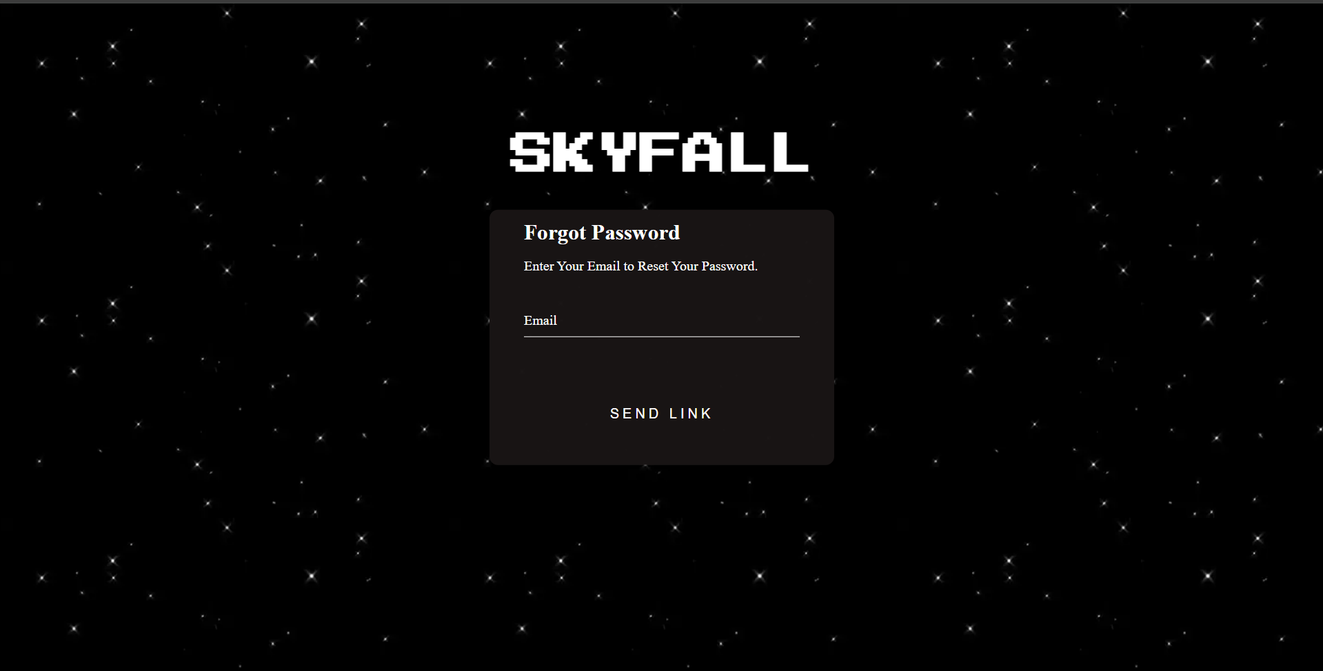

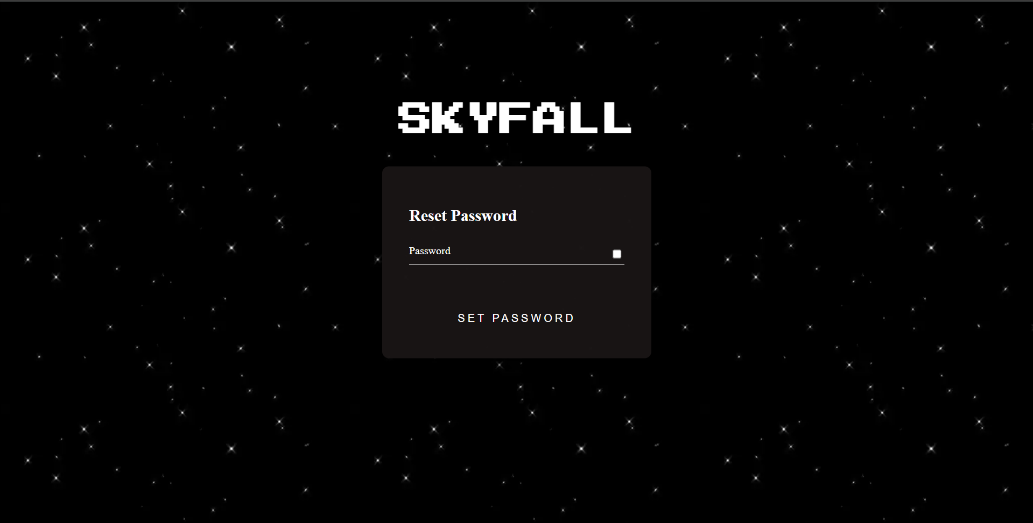

This interface will come when clicking on the reset password link in the email and user can set their new password.

##### Home page:

After user login into the site then he/she can see main page /play interface of the page.

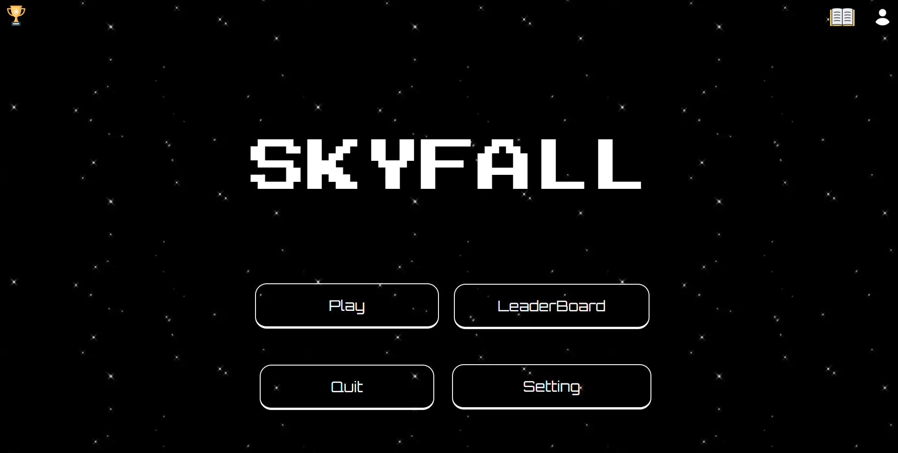

On the top right-side user can see there user profile in that user can change there profile picture/avatar that are given it. And there is an option of logout if user wants to logout.

On the top left-side user can see achievements of the game. Also see that which he/she has completed and which not has been completed on that user profile

In the middle there is name of game.

From below of its user can see play button by on click it. He/ She can select the difficulties of the game and there are three types of difficulty are there Easy, Medium, Hard. These are the three types of different difficulties.

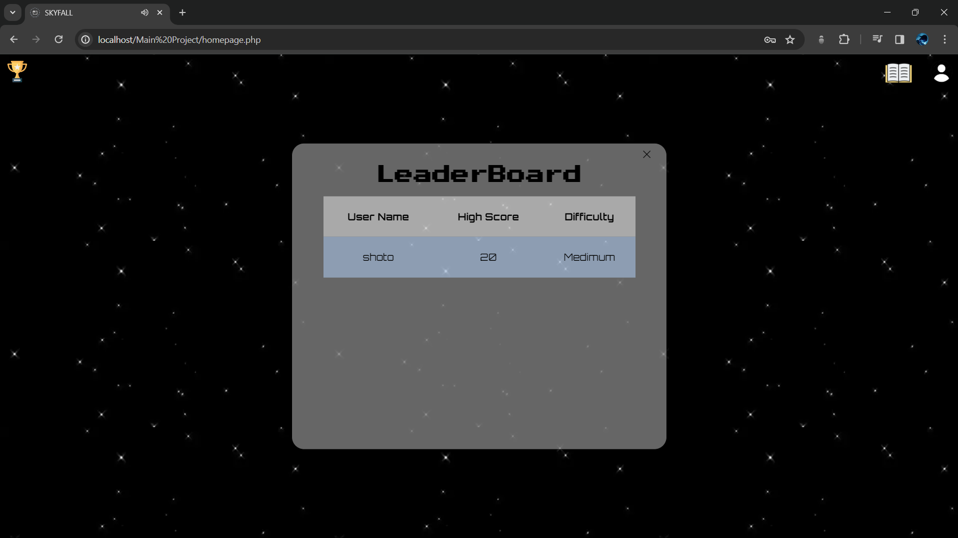

When user clicks the leaderboard option user can see their score and rank in this interface.

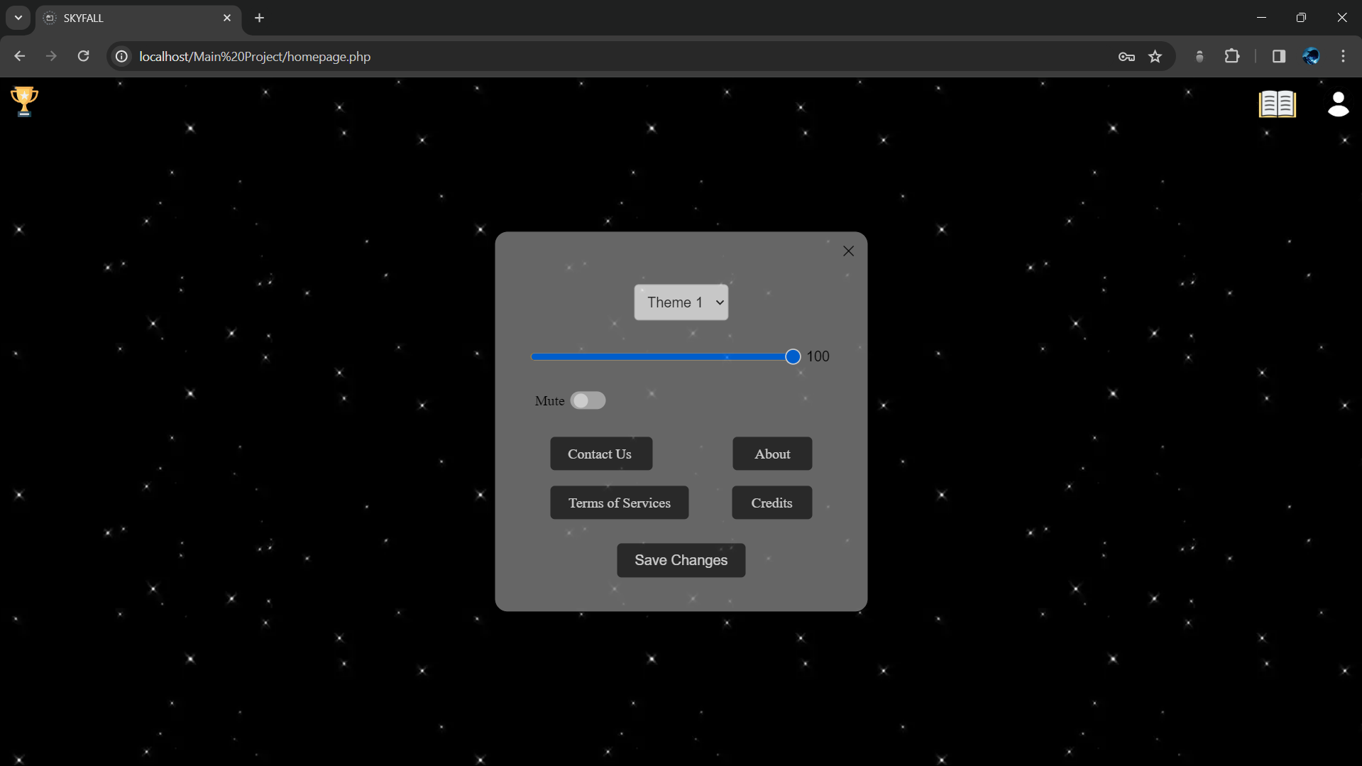

In the settings option, the user can change the theme song if they want to and also a there is a mute option and there are several options available like Contact us, About, Terms of Services, and Credits. Also after user changes their settings they can save changes to confirm their final results.

##### Achievements:

In achievements there are some achievements are created so user can see game more iterative and make it more enjoyable to play game.

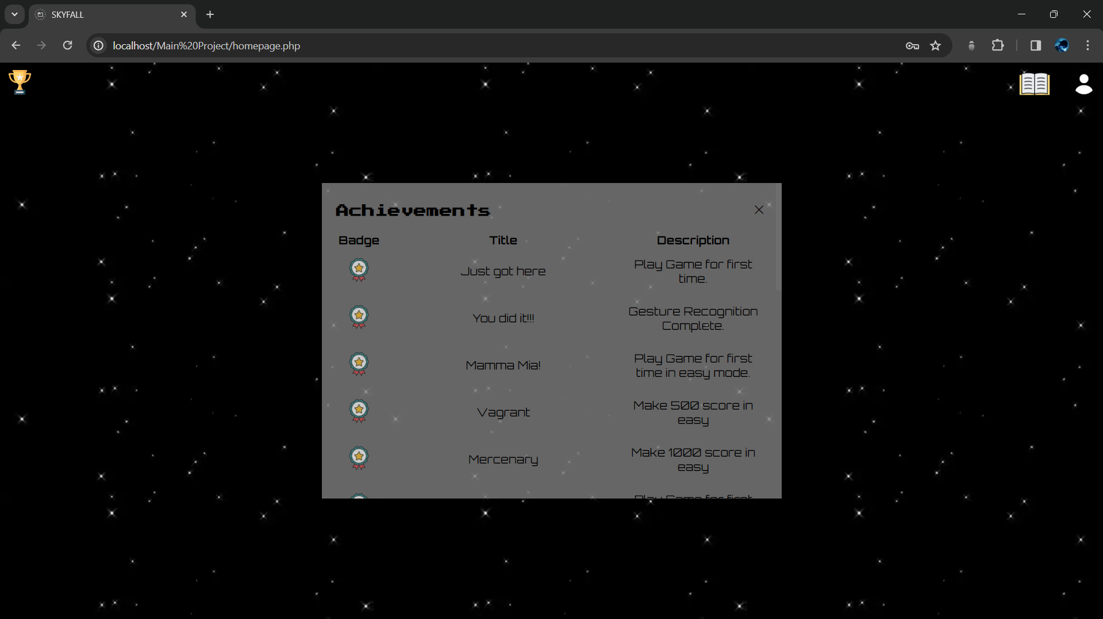

There are so many different kinds of achievements are there and, in every difficulty, have their own kinds of achievements. And there are some achievements for even whole game. This will make user more enjoy the game.

##### User-Profile:

Is there where user profile is there if user want to see their profile.

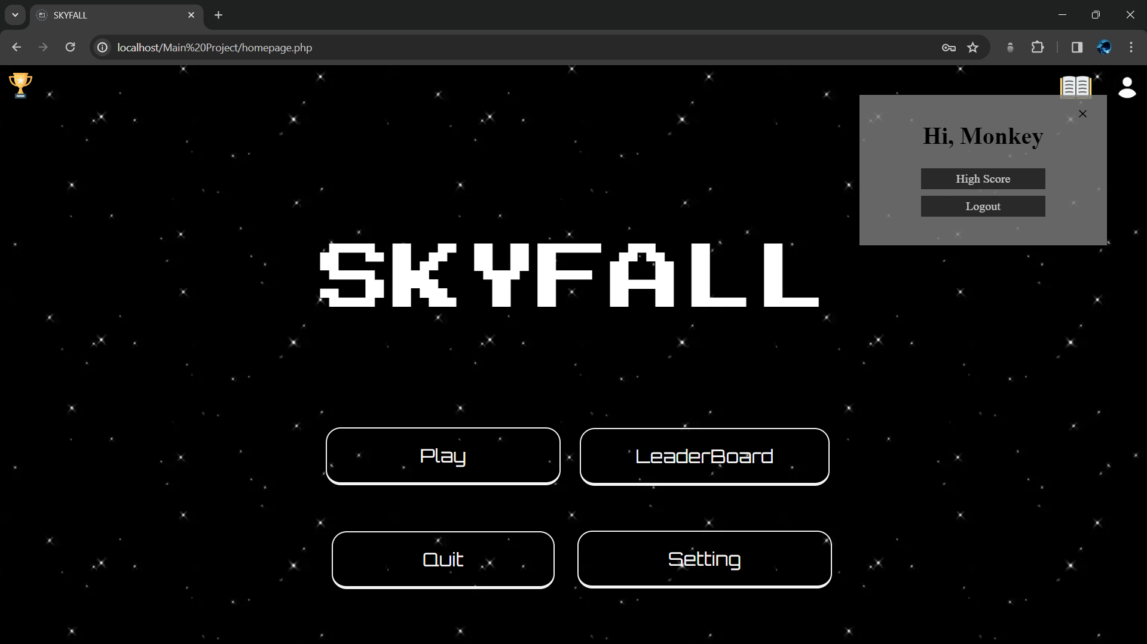

The user profile is on top right side of the page. In that user can see their user-name. If user wants to changes there user-icon/avatar of there profile then they can do that by clicking on the Change Profile Picture or if user wants to logout there account then they to that also and they account will be logout.

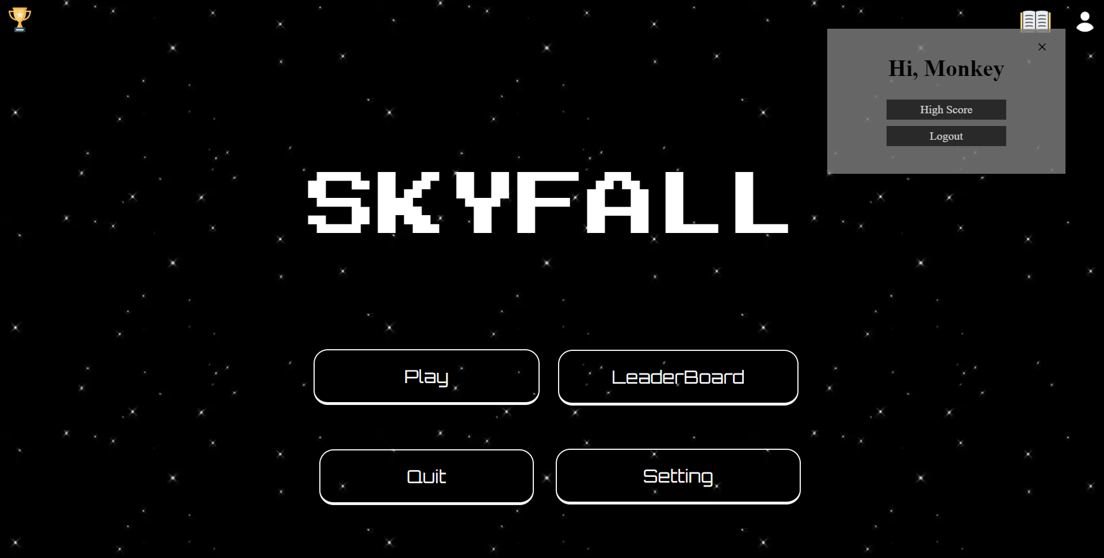

There’s a High Score option in the Profile Section through which they can see their High Score of the particular Difficulty.

##### Set Difficulty:

When user click on Play button then user have to select the difficulty

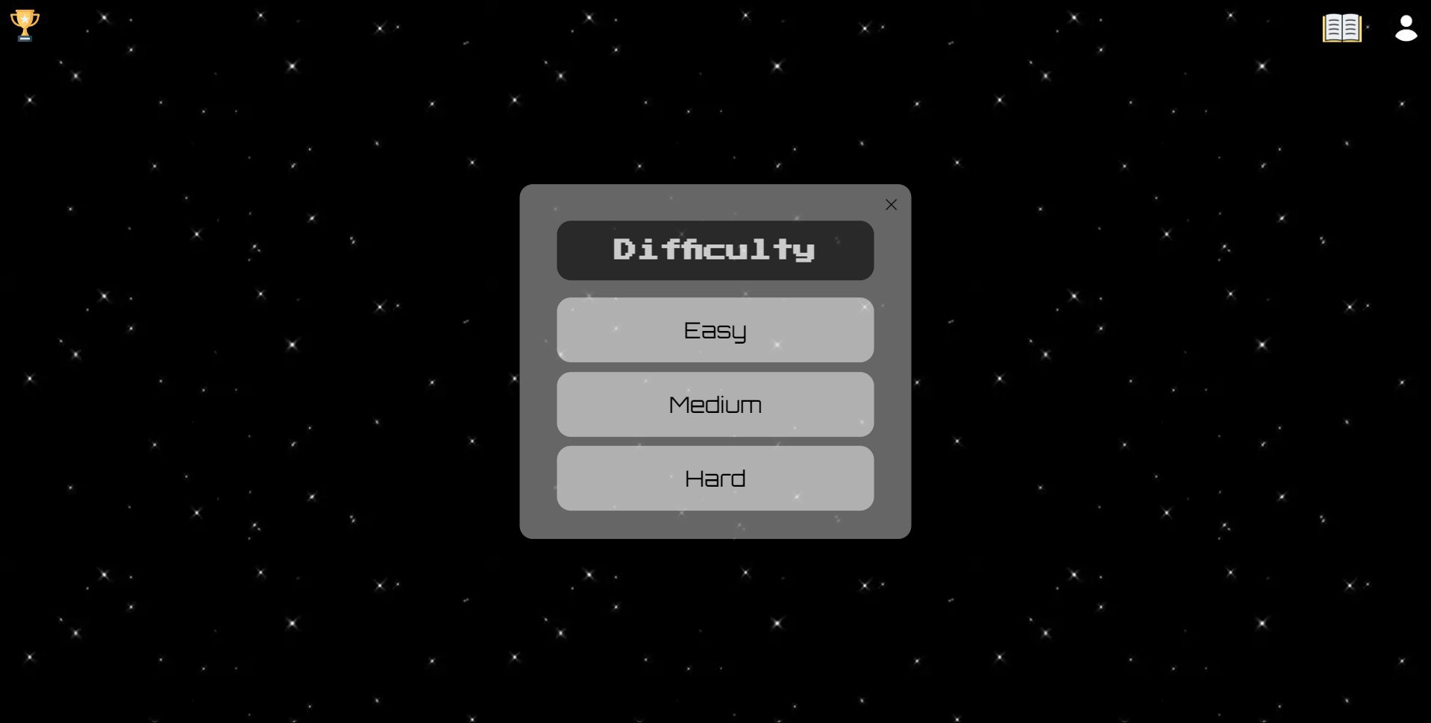

There are three types of difficulty Easy, Medium, Hard. All three difficulty will work as it named in Easy difficulty it will be easy gameplay, in Medium difficulty it will be medium gameplay it will be hard then Easy difficulty and easy then Hard difficulty. And if user wants to go back at main page, then he/she close this by clicking close button.

##### Easy Difficulty:

This is how easy difficulty game interface looks.

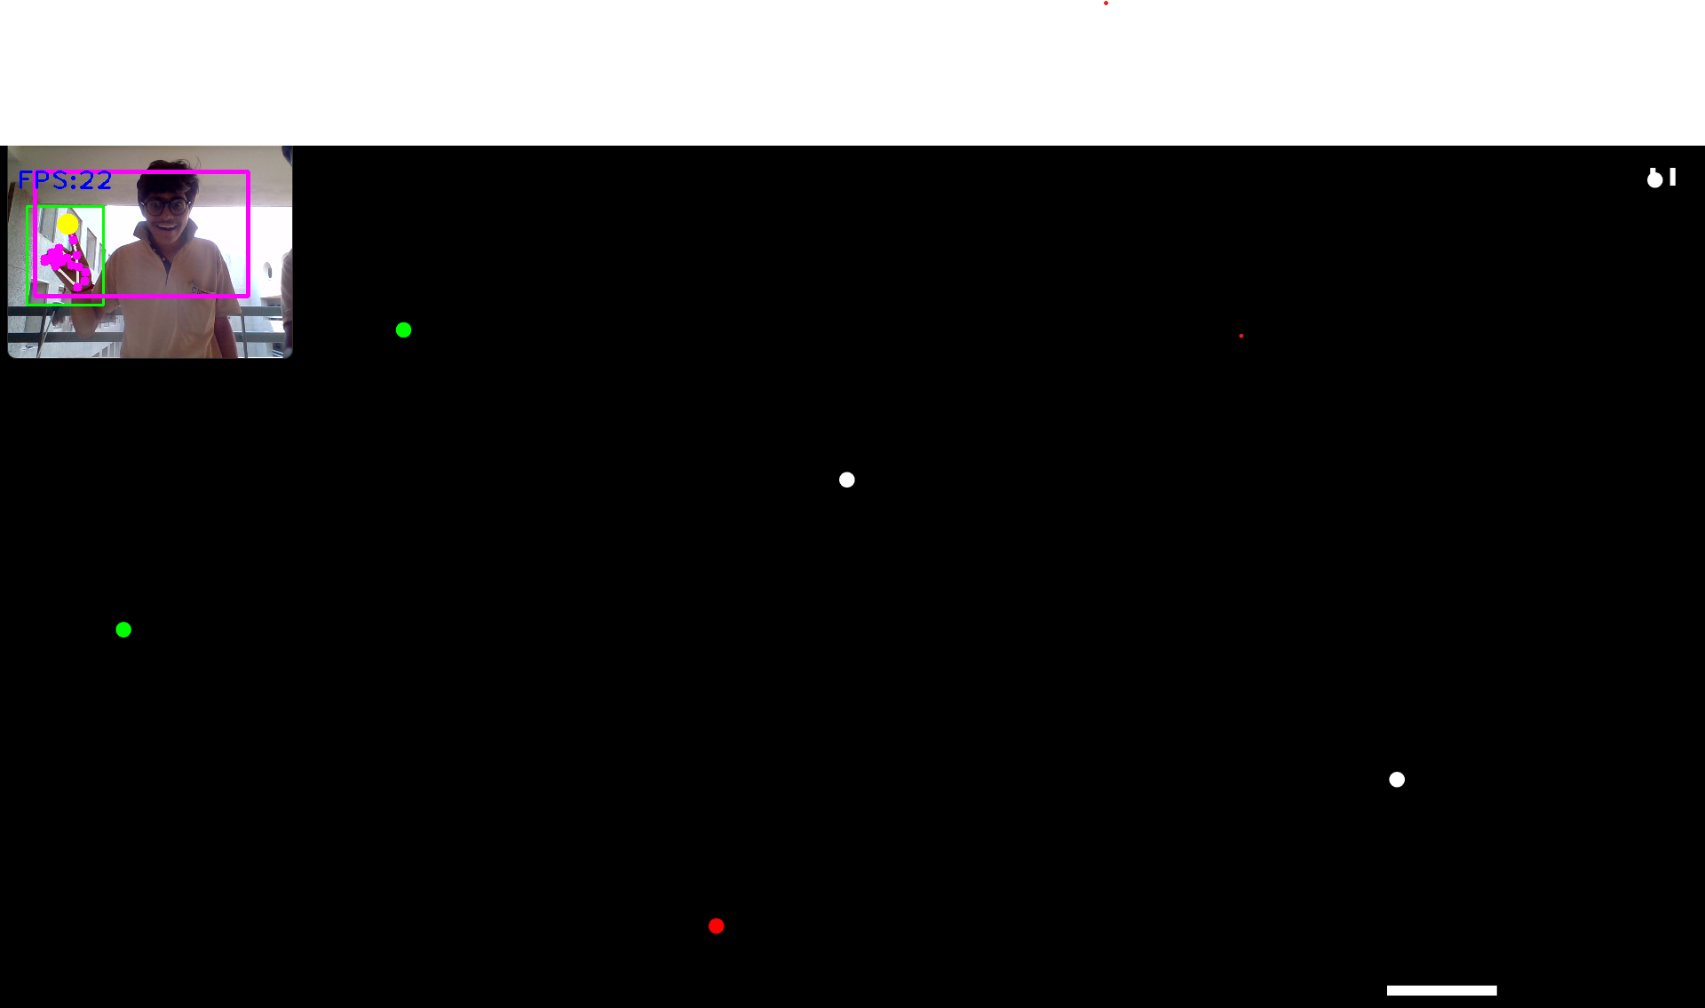

There are on left-top there is Score board and on top-right side there is option of pause menu if user wants to pause the game in the middle of the game then its comes handy. And in pause menu there user get some options.

##### Pause screen:

This screen comes when user pause game.

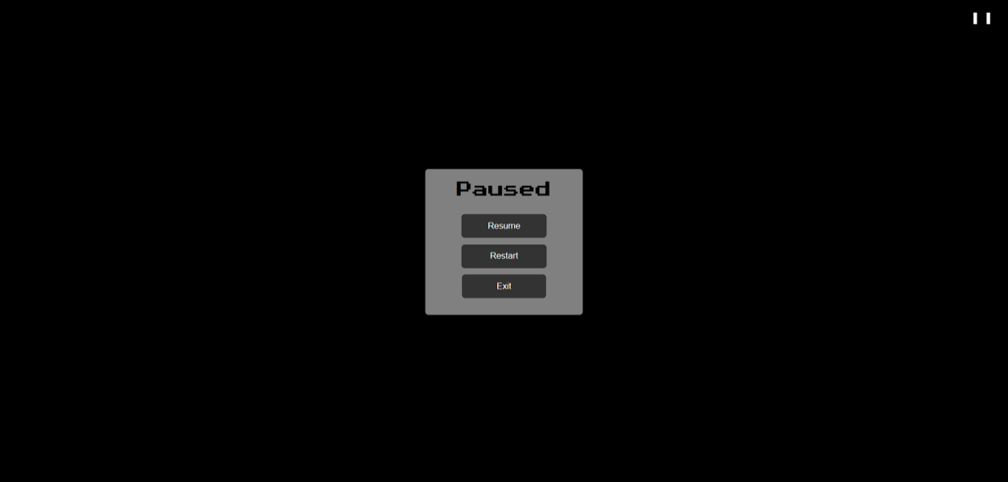

There are three options are there.

Resume:- In resume the game will start where user has pause game. And this score will be same before and after also.

Restart:- In restart the that mode/difficulty. And this score will be reset and new game will start.

Exit:- In this that selected mode/difficulty will be exit.

##### Game Over:

After the game has been played. if user will lost all lives then game will be over.

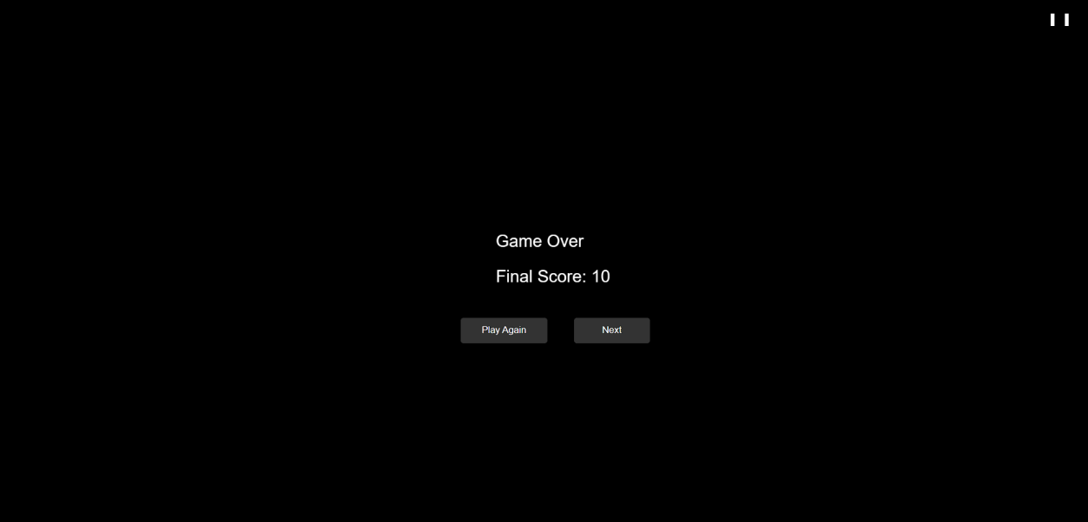

There are two options if user wants to play again and user wants to exits the game. In Play Again option the game will start again and in Next option it will goes to main page.

##### Guide Book:

##### There’s a Instruction Manual for users if they don’t know how to play game.

##### 

##### Through this Manual, user can know about the game and play experiencedly.

##### Quit Button:

In the Quit button this is how it works.

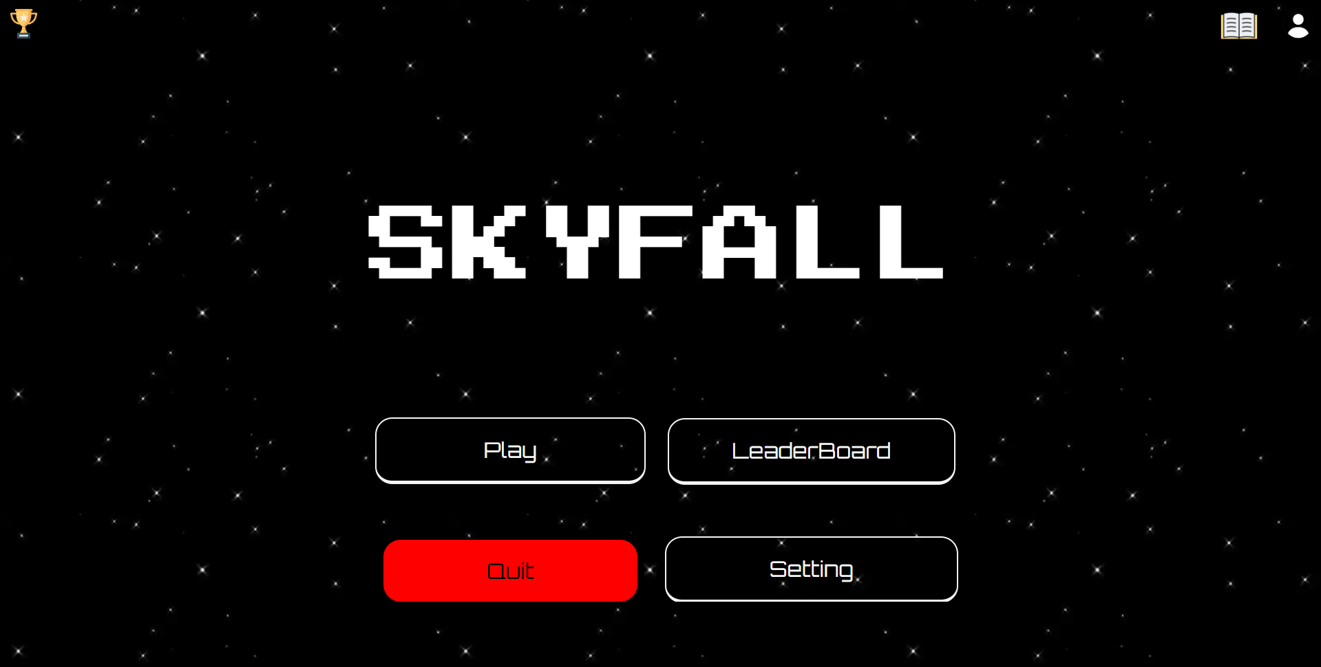

If the Quit button is click by mistake, then the conformation tab will allow user for confirm the action.